Experiment 12

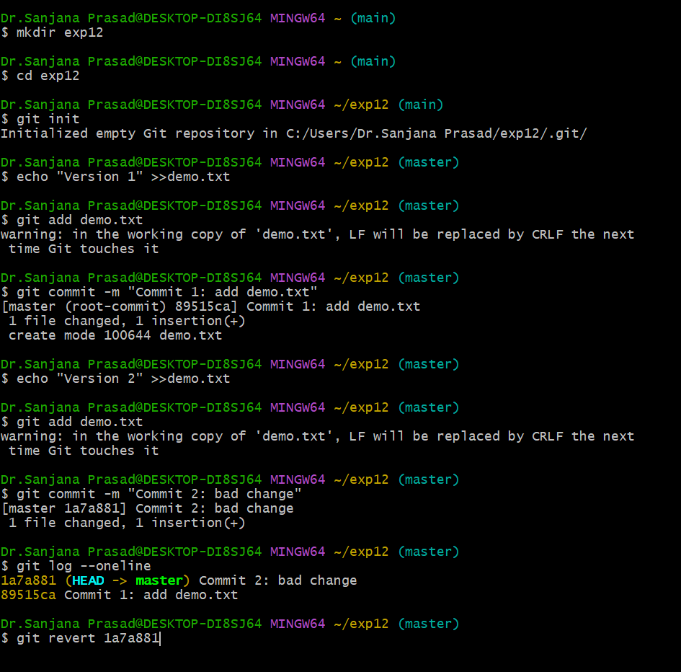

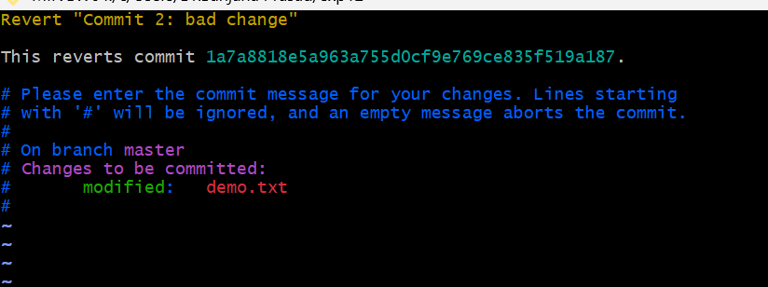

Press Esc
Type :wq
git log –oneline
xxxxxxx Revert "Commit 2: bad change"
7dd2a50 Commit 2: bad change
...

